1

Case Study Background
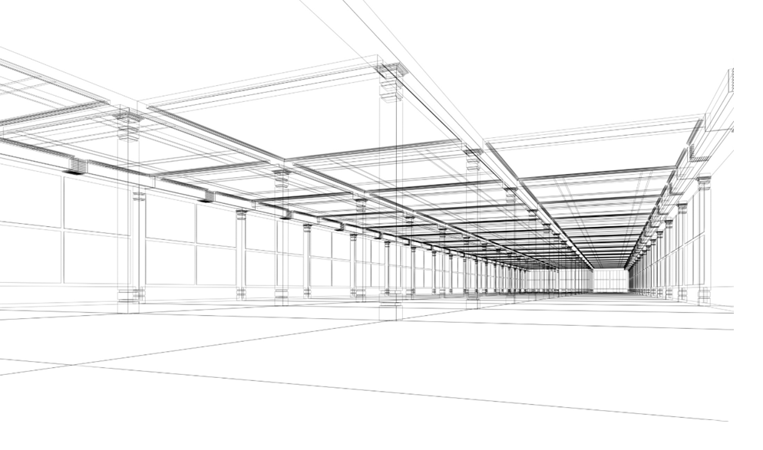

Version: 7

Table of Contents
1. Introduction 3
1.1 Purpose of this document 3
1.1 Reading guide 3
1.2 Definitions 3
2. Case Study Background 5
2.1 Introduction 5
2.2 The client 5
2.3 Business purpose 5
2.4 Scope of the project 6
2.5 Existing client environment 6
3. Business requirements 7
3.1 Business Process 7
3.2 Census Form 8

Table of Figures
Figure 1 - Census business process illustration 7
Figure 2 - Census form structure 9

Introduction

Purpose of this document
This document is part of the case study materials for the Architectural Thinking Workshop course. The course uses a single case study where you, as a participant, play the role of lead architect during a proposal that has already started.

Reading guide
This document should be read in its entirety prior to starting the course. It should then be used as a reference during the course.
This document will not provide you with all the information you will need to complete the solution, therefore you will need to elicit additional requirements in client role plays during the course. Think about what other information you will need as you are reading this document and write down questions that you will ask the instructors to clarify and expand your understanding of the problem.

Definitions
Table 1. List of Terms and Acronyms.
Term / Acronym | Meaning
Bolumbia Post | The mail and parcel delivery service in Bolumbia.
Census | The Census of Population and Housing provides a snapshot of Bolumbia's people and their housing. The Census is the largest statistical collection undertaken by the DoS and one of the most important. Its objective is to accurately measure the number and key characteristics of people who are in Bolumbia on Census Night, and of the dwellings in which they live.
Census Night | While respondents may submit their responses during the entire enumeration period, questions must be answered for the situation in the dwelling on Census night.
CFN | The CFN is a unique number assigned to each dwelling by the Census Collector upon delivery of the paper Census Form. The format of the CFN is:  Where:  - CWL: Is the Collector Workload (CWL) (approximately 27,000 CWLs) followed by its alpha CWigit (CD)  - RNO: Is a sequential number issued by the collector when delivering forms called the RNO (Record Number) followed by its alpha Check Digit (CD).  The CFN and ECN are used by the respondent as credentials to logon to ECS.
CWL | The seven digit Collector Workload (CWL) component of the CFN code. There will be approximately 27,000 CWLs. Refer to CFN.
DoS | Bolumbia’s Department of Statistics
Dwelling | A dwelling is an important legal concept which defines a self-contained unit of accommodation used by one or more households as a home, such as a house, apartment, mobile home, houseboat or other 'substantial' structure.
ECN | The ECN uniquely identifies a Census form. The ECN format is as follows:  Where:  - There is a first 8-digit random sequence followed by 4 check digits.  The ECN and CFN are used by the respondent as credentials to logon to ECS.
ECS | The Electronic Census System is the subject of this document.
Enumeration Period | Period during which Census response must be submitted.
PD | Private Dwelling (refer to Dwelling)
RNO | RNO (Record Number) is a four digit sequential number part of the CFN which is issued by the collector when delivering forms. Refer to CFN.

Case Study Background

Introduction
The proposal is for the Republic of Bolumbia’s Department of Statistics. The Department of Statistics (DoS) wants to implement a new Electronic Census System (ECS) for the next population Census to complement the existing manual process for collecting information about the current population.
The client has asked for a proposal for the delivery of an Electronic Census System. A team has been assembled to respond to this client request. Some work has already been started. The lead architect who started as part of the proposal team is no longer available to work on the ECS proposal and you have been called to take the role of the lead architect.

The client
Our client is the government of the Republic of Bolumbia, a prosperous country with a population of over 23 million people.
The government has a Department of Statistics (DoS) which collects and analyses information about various aspects of the country including its population, society, health and the economy to name the key areas. The department has been running a Population and Housing Census for over 100 years and in recent history the Census has run every 5 years, the next census being three years from now.
The mis the DoS is to assist and encourage informed decision making, research and discussion within government and the community, by leading a high quality, objective and responsive national statistical service.
DoS is looking for an IT partner to deliver the complete ECS solution including implementation, hosting and support.

Business purpose
The Census of Population and Housing is the largest statistical collection undertaken by the DoS and one of the most important. Its objective is to accurately measure the number and key characteristics of people who are in Bolumbia on Census Night, and of the dwellings in which they live. This information provides a reliable basis for estimating the population of each of the provinces and local government areas, primarily for electoral purposes and for planning the distribution of government funds. Census data are also used by individuals and organizations in the public and private sectors to make informed decisions on policy and planning issues that impact on the lives of all Bolumbians. Everyone in Bolumbia is legally required to complete a Census form, to ensure that the Census data give an accurate and complete picture of the nation.
To date the Census has been done by manually distributing and collecting paper forms from each household and business in the country before entering this information into a computer system. In line with DoS’ continual improvements program, effort h as been expended in order to improve and expand communications channels to, and from the public. The ECS initiative represents a significant step in this process as it embraces the internet as a viable, and powerful, communications medium.
ECS needs to provide the Bolumbian population with the ability to complete the next Census Form electronically over the Internet, with a solution that does not require any software other than desktop internet browser on the respondent’s computer and/or mobile app on the respondent’s mobile device. The next Census will occur in 3 years’ time.
Thus the ECS initiative addresses the following DoS objectives:
- Responds to public requests for increased flexibility in methods of completing Census materials.
- Capitalizes on the internet as a viable communications channel.
- Meets DoS obligations under the Electronic Transactions Act 2009.
- Provides online support of the 2016 Census.
- Maintains the privacy & perception of privacy, in that DoS holds a unique security access key to the managed data, and only staff employed under the Statistics Act can access the raw respondent data.

Scope of the project
You are asked to propose an ECS that includes the following elements:
- Definition of a solution for capturing Census information electronically via the internet using a desktop or mobile device, through the Census period.
- Implementation of the solution including testing and production deployment.
- Use a cloud-based environment to host services during the length of the project (i.e. through development and production) to optimize DoS infrastructure investment and provide maximum flexibility to increase or decrease infrastructure resources in line with demand.
- Support services for the application and infrastructure (i.e. full support for the overall solution).
The ECS proposal does not include:
- Systems to analyze Census information collected (this is the subject of another proposal).
- Non-private dwellings: These responses will be ppaper-based for this first release of ECS.

Existing client environment
The ECS is a new system therefore there are no existing environment constraints as far as the core ECS solution is concerned. However, there are constraints in terms of the client environments that need to be supported including Operating Systems, Browsers, network bandwidth, etc.
The ECS will need to integrate with other DoS systems and there are various options that can be explored in terms of middleware and communication style.

Business requirements

Business Process
The figure below [Figure 1] illustrates the overall Census business process and its major components. The numbered text following the figure describes the principle business flows as marked in the diagram. The blue shaded area [New ECS Hosting Environment] shows the scope for the new ECS Hosting Environment and the focus of this document.
Figure 1 - Census business process illustration
The overall Census process of which ECS is one part occurs as follows.
- The ECS application will be developed, and tested by your organization’s application development staff, then installed into the Production hosting environment for DoS User Acceptance Testing, and updated with any fixes ready for production use.
- At the beginning of the Census enumeration period ~27,000 Census Collectors deliver Census forms to each of the approximately 9.5 million households in Bolumbia. Along with their Census form each household receives an envelope containing their ‘Electronic Census Number’ and instructions on how to use this and their Census Form Number to do their census response on line using ECS.

- During the enumeration period which runs during the month of August, a Census return must be completed for each dwelling/household. The Census response can be made at any time during the enumeration period; however the questions must be answered for the situation in the dwelling on Census night (the first Tuesday of August, 3 years from now). Due to this requirement many respondents complete their Census response on Census night.
- Respondents have the option of either completing a paper Census form collected by the Census Collectors, or completing their Census online using ECS. The ‘Electronic Census Number’ and ‘Census Form Number’ delivered with their Census form are used as access credentials for ECS. Respondents may also mail their forms back via Bolumbia Post.
- The ECS system transfers the Census Form Number (CFN) and address details of respondents who complete their Census return using ECS to the DoS Electronic Census Processing system.
- These details are sent to the appropriate Census Collector via an SMS message, enabling them to remove these addresses from their collection lists.
- The ECS system transfers all newly submitted ECS returns to the DoS Electronic Census Processing system. The Electronic Census Processing system transfers this data to the DoS Census database. This transfer of data is depicted by the red lines and arrows in Figure 1.
- The Census Collectors return to all dwellings remaining on their collection lists to collect the completed paper Census forms. These forms are processed by the DoS Forms Processing system and the resulting data loaded into the DoS Census database. The business flow of paper Census forms is indicated by the green arrows in Figure 1.
- The ECS system is monitored and supported by your organization’s staff in the hosting support groups.
- A Census help desk is provided by the DoS to handle respondent questions regarding completion of the Census form, or use of ECS. Your organization’s development group provides the help desk with ECS application usage information to support the application.
- Daily reports and other information pass between your organization and the DoS to support ECS operation as indicated by the solid black arrow in Figure 1.

Census Form
This section briefly describes how the Census Form is structured. The word form is used to describe the complete census response completed by a respondent. The form includes multiple sections containing questions and each of the sections can have one or more pages.
Please note that page refers both to a physical page in the paper form as well as an electronic page displayed in the user’s desktop or mobile application by the ECS.
The following diagram in Figure 2 shows the Census Form structure.
Figure 2 - Census form structure

The Census Form comprises 4 sections as can be seen in the Figure 2 diagram:
- Address section: One page with the dwelling address details.
- Person section: This section comprises 21 pages on average. There are 50 questions per person, which at around 7 questions per page equate to 7 pages. There are approximately 3 persons per dwelling on average (23 Million people divided by 9.5 Million dwellings); therefore there is an average of 21 pages for the person section.
- Dwelling section: This section comprises 6 pages on average based on 10 questions and the same logic applied to the person section (i.e. 2 [pages] * 3 [people] = 6 [pages]).
- Feedback section: One page with respondent feedback captured before submitting the complete form.
CREAMOS LA SUPOSCUCION DE QUE YA LAS CASAS ESTAN CREADAS

